**The Impact of Harm Reduction Policies and Programs on Health Equity in the United States: A Scoping Review: Search Strategy**

# 

**Topic 1: Harm reduction and equity**

# String 1: “Harm reduc*” AND equity

* 150 results returned
  + 118 excluded, 32 potentially relevant

**String 2: ("overdose prevention site" OR “safe consumption” OR “injection facility") AND (HIV OR HCV OR hepatitis)**

* 83 results returned
  + 72 excluded, 11 potentially relevant

**String 3: ("syringe services" OR "syringe access" OR "syringe exchange") AND (equity OR disparity OR disproportionate) AND (hepatitis OR "HCV" OR "HBV" OR "HAV" OR “HIV”)**

* 24 results returned
  + 11 excluded, 13 potentially relevant

**String 4: (MOUD OR buprenorphine OR methadone) AND ("syringe services" OR "syringe access" OR SSP)**

* 46 results returned
  + 38 excluded, 8 potentially relevant

**Topic 2: Harm reduction and race/ethnicity**

**String 1: “Harm reduction” AND race**

* 233 results returned
  + 180 excluded, 53 potentially relevant

**String 2: ("syringe service*" OR "syringe access" OR "syringe exchange") AND ("Black" OR "Hispanic" OR "Latin*" OR "race" OR “equity”)**

* 129 results returned
  + 81 excluded, 48 potentially relevant

**String 3: ("syringe service*" OR "syringe access" OR "syringe exchange") AND (“African American”)**

* 30 results returned
  + 26 excluded, 4 potentially relevant

# Topic 3: Harm reduction and LGBTQ+ individuals

# String 1: "Harm reduc*" AND ("LGBT" or "gay") NOT chemsex

* 115 results returned
  + 83 excluded, 32 potentially relevant

**String 2: "harm reduc*" AND “chemsex”**

* 48 results returned
  + 44 excluded, 4 potentially relevant

**String 3: ("syringe services" OR "syringe exchange" OR "syringe access") AND (lgbt* OR lesbian OR gay OR bisexual OR queer OR transgender)**

* 36 results returned
  + 28 excluded, 8 potentially relevant

**Topic 4: Harm reduction and criminalization**

**String 1: “arrest” AND ("syringe access" OR "syringe services" OR "syringe exchange")**

* **76 results returned**
  + 61 excluded, 15 potentially relevant

**The Impact of Harm Reduction Policies and Programs on Health Equity in the United States: A Scoping Review**

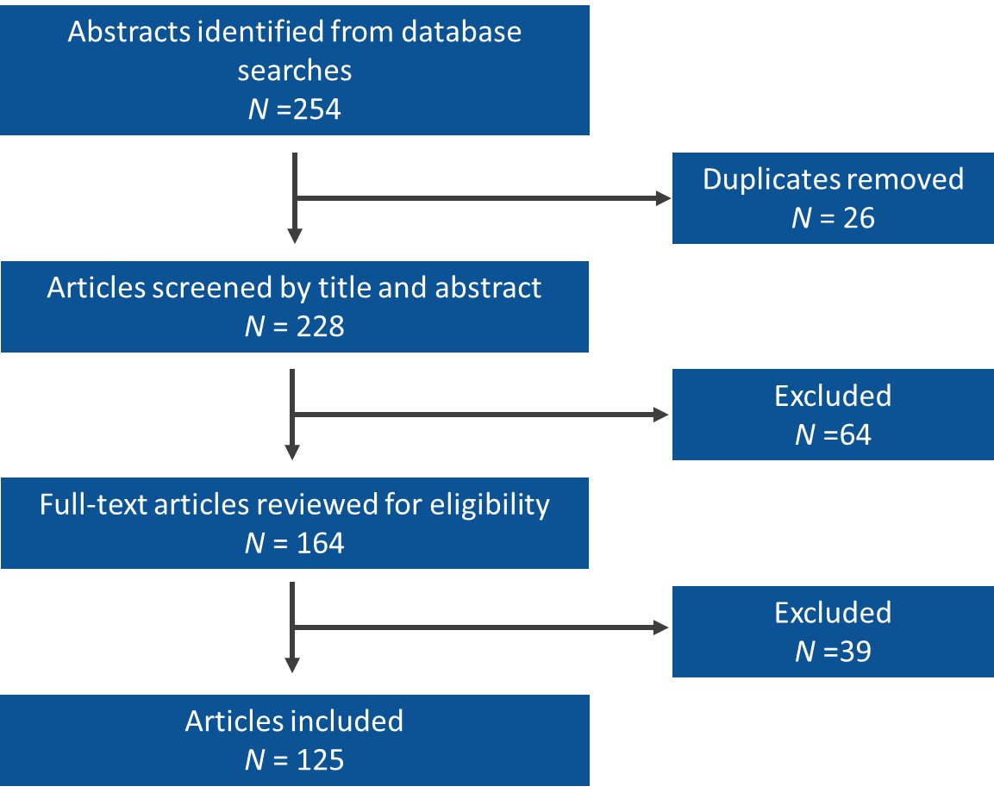**Search strategy flowchart**